Install Spark - Local mode in Windows machine

1. You need to have Administrator rights on your laptop / machine.
2. You don’t need to install ‘scala’ separately. It’s inbuilt with Spark package.
3. You don’t need ‘Hadoop’ to work with Spark in local mode.
4. Download apache Spark stable release - <https://spark.apache.org/downloads.html>

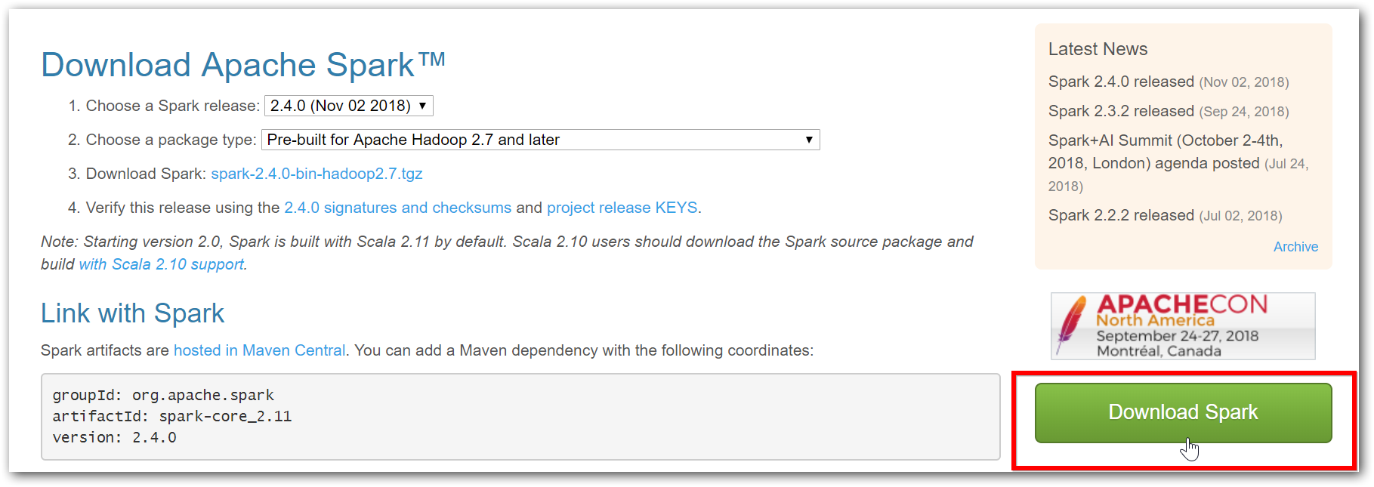

1. Download ‘winutils.exe’ based on your machine’s configuration - <https://github.com/steveloughran/winutils/tree/master/hadoop-2.7.1/bin>
2. Save ‘winutils.exe’ binary to a directory of your choice, e.g. “D:\Hadoop\bin”.

This doesn’t mean that Hadoop should be installed. Simply have directory like above.

1. Set HADOOP_HOME in environment variables (without bin),

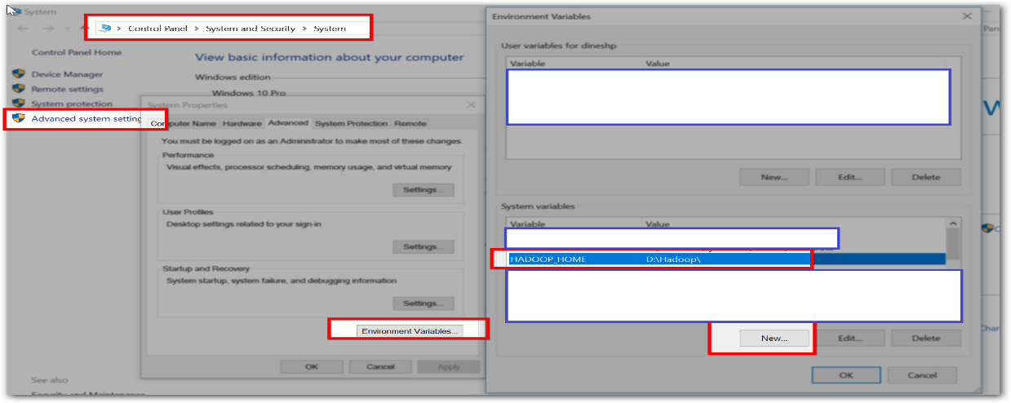

SPARK_HOME is not necessary. But if you have already set, then for this installation, you should set Spark installed path without ‘bin’ directory as SPARK_HOME.

1. Open “spark-shell.cmd” and observe the output (perhaps with few WARN messages that you can simply disregard).

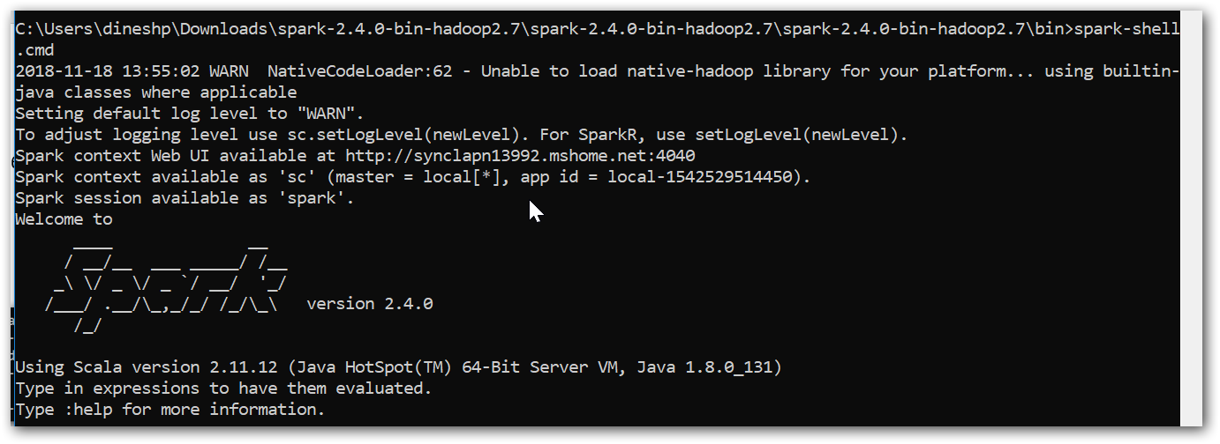

1. As a verification step, execute the following line to display the content of a DataFrame:

scala> spark.range(1).withColumn("status", lit("All seems fine. Congratulations!")).show(false)

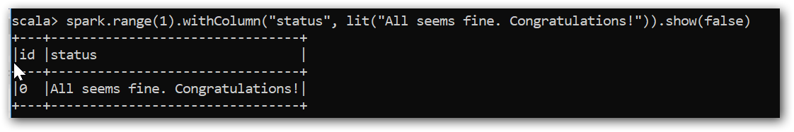

1. And its all set. You can tryout samples in scala language on your own.

<https://spark.apache.org/examples.html>